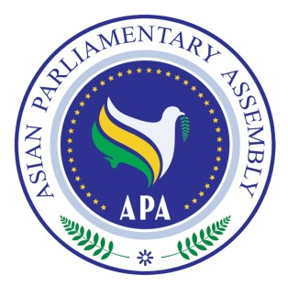
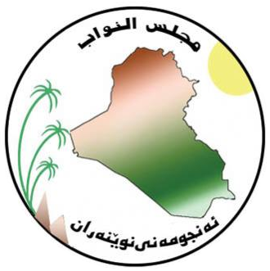
The Meeting of APA Standing Committee on
Budget and Planning
3 - 5 September 2019
Baghdad, Iraq

Draft Agenda

1- Adoption of the Agenda
2- Election of the Bureau
3- Opening Remarks by Chairperson
4- Report by APA Secretary General
5- Consideration of:

- Draft Resolution on Planning APA Budget

6- Any other matters

As of 13 July 2019

